

# WEBSTACK DEVELOPMENT PROJECT

**ETE - 3**

INTERIOR DESIGN WEB PROJECT: WEDESIGN

### SUBMITTED BY:

Kumkum Rathi

Reg No:2447231

Shobha Mary

Reg No:2447247

# Interior Design Website Documentation Report

## Introduction

The Interior Design Website project aims to create a visually appealing platform for clients to explore various interior design services and portfolios. The website offers an easy-to-navigate interface, allowing users to view completed projects, request consultations, and browse through design ideas for different spaces such as living rooms, kitchens, and offices. The responsive design ensures usability across all devices.

## Technologies Used

• **HTML5/CSS3**: To create the structure and style of the website.

• **JavaScript**: For dynamic elements and enhancing user interaction.

• **Bootstrap**: CSS framework used for responsive and modern layout designs.

• **Node.js**: Server-side scripting for handling client requests.

• **MongoDB**: Database for storing client inquiries, portfolios, and testimonials.

## Functionalities

### Project Showcase

#### HTML Page:

#### index.html

* + **Description**: Main Page which contains all the sub sections :

1. About Us
2. Services
3. Gallery
4. Client Reviews
5. Visit Us

**Registration.html**

**Description:** This web page contains a form which stores in the details sentered by the user into the database

**Map.html**

**Description:** This web page is used to display the Map, Geo Location, upon clicking on this option the user get navigated to the location of the firm

1. **Backend Structure**

Backend done using Mongo DB and Node JS via Express.js

. app.js

.user.js

.hbs files

## How the Project Works with Local MongoDB Server

The app.js file connects to a MongoDB instance, storing client inquiries, testimonials, and portfolio details. Key functionalities include:

• **Client Data Model**: Defined using Mongoose, it specifies the structure of client details and project information.

• **User Registration for Designers**: Designers can log in to update portfolios or manage consultations.

**RESULTS**

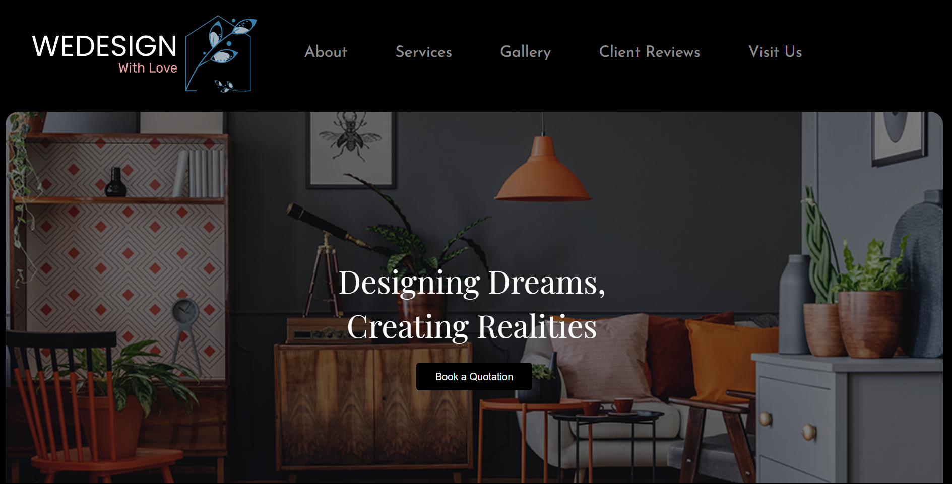

**Main web page with sections**

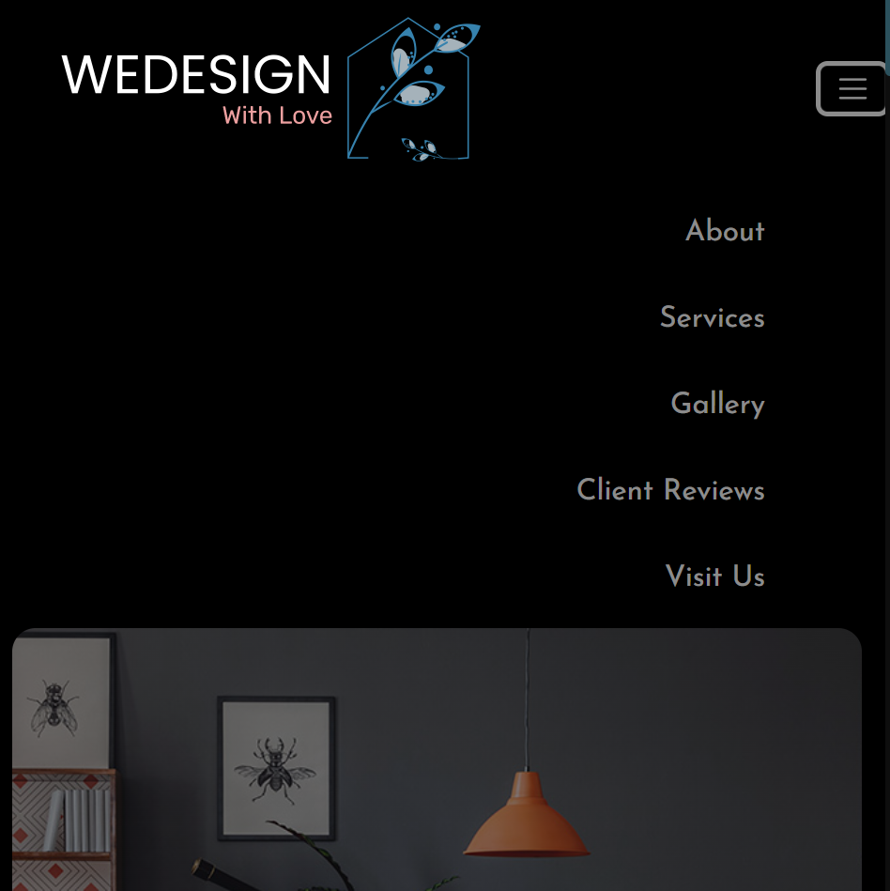

**Use of Bootstrap nav bar**

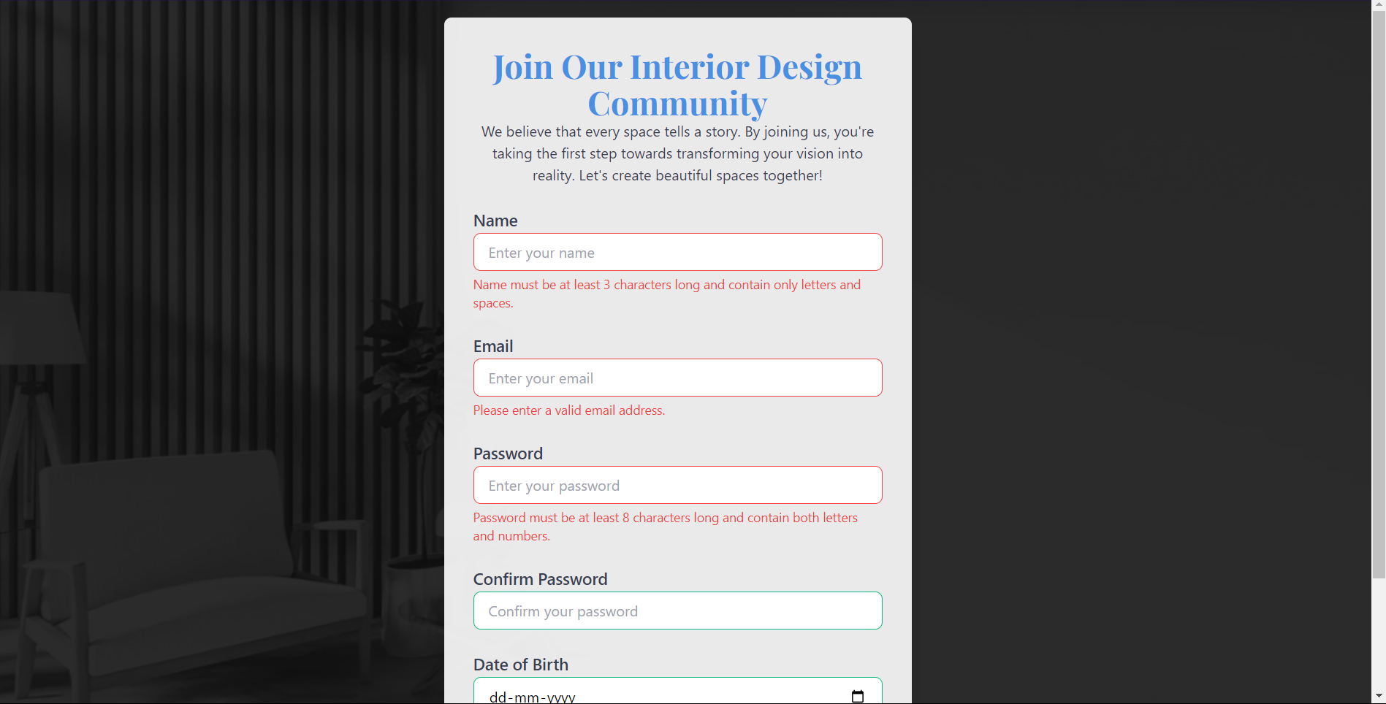

**Registration.hbs , with validations**

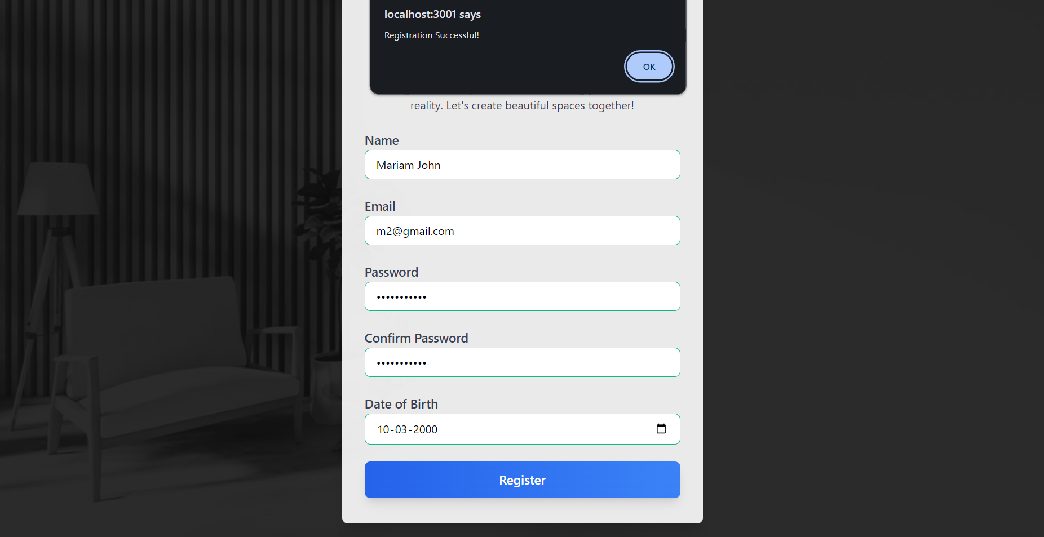

**Upon successful registration**

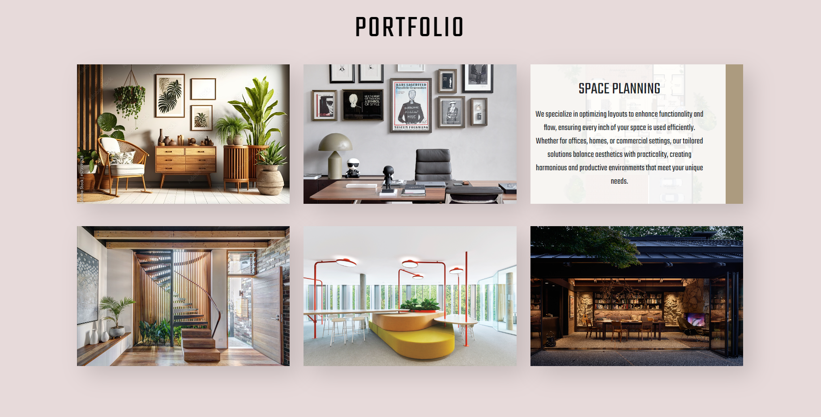

**CSS FlexBox**

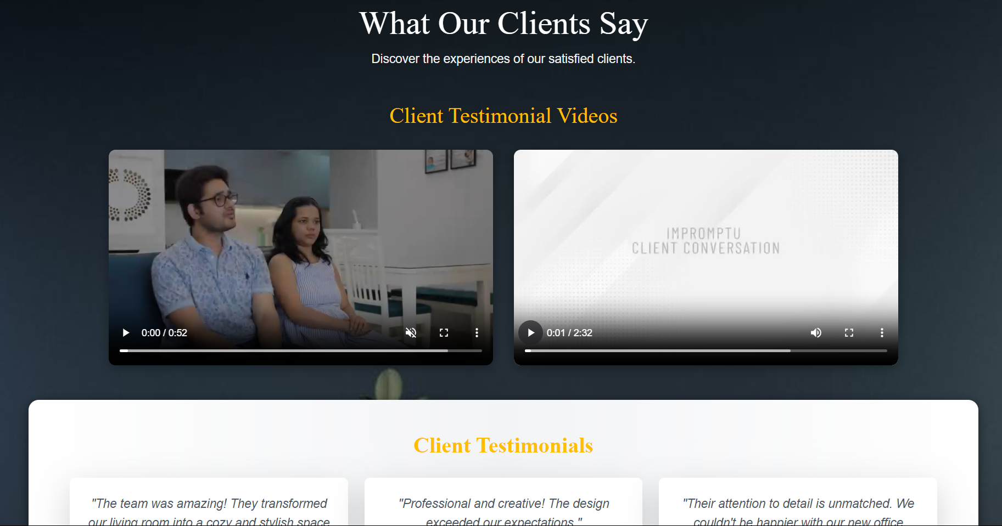

**Video integration**

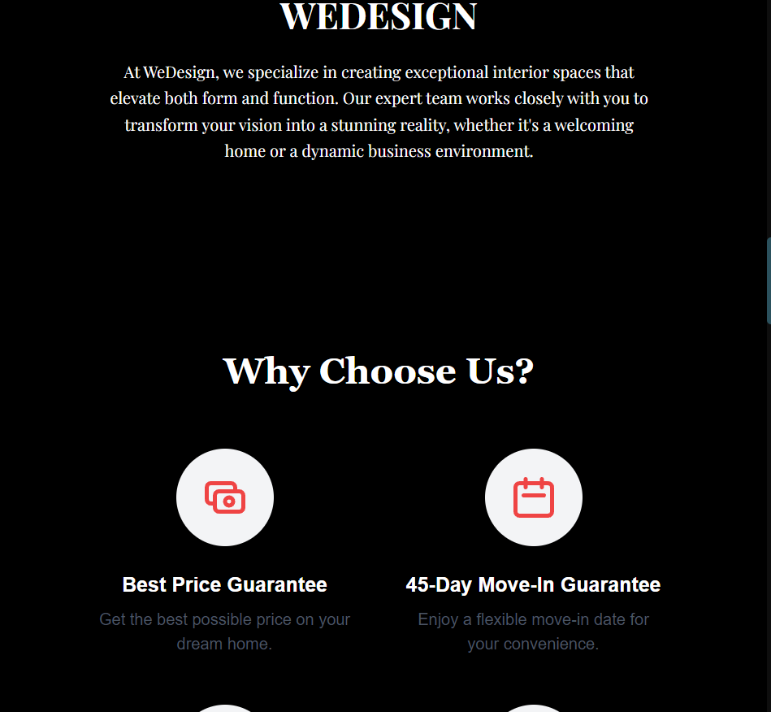

**Media queries**

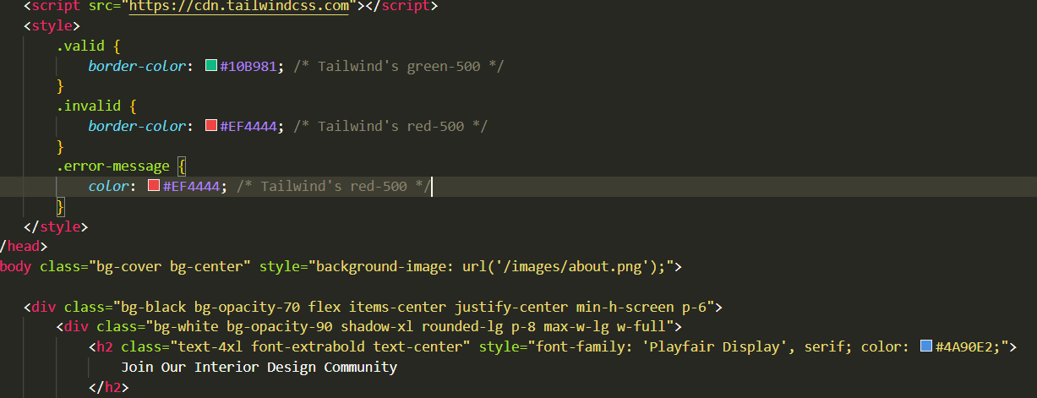

**Use of CSS tailwind**

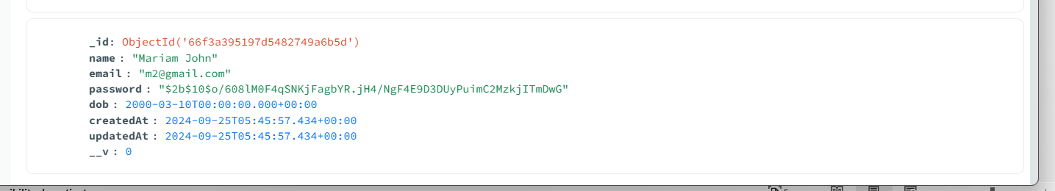

**Stroage of data in MongoDB**

## Conclusion

The Interior Design Website provides an interactive platform for showcasing design projects, booking consultations, and accessing detailed service information. The website's seamless design, user-friendly interface, and secure client management system ensure a high-quality experience for both designers and clients.

## Conclusion

The Interior Design Website provides an interactive platform for showcasing design projects, booking consultations, and accessing detailed service information. The website's seamless design, user-friendly interface, and secure client management system ensure a high-quality experience for both designers and clients.